ECE 4980 Individual Deliverables

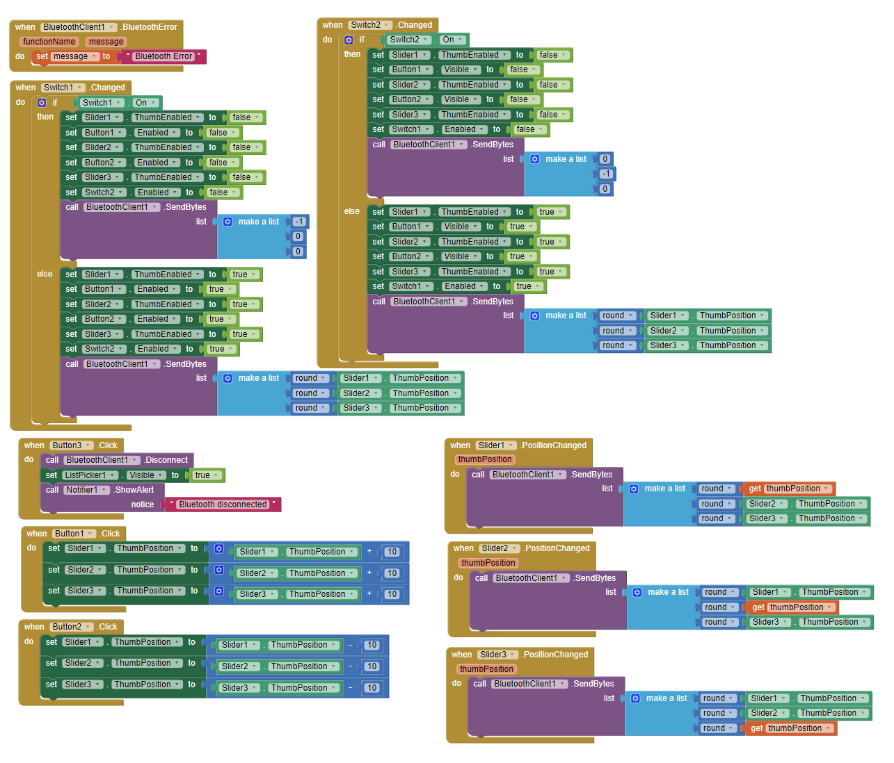

Figure 1. Code blocks for 2A1 App Controls developed with MIT App Inventor 2

Note: APK file attached works using USB debugging on my Google Pixel 3 XL Android phone. The Bluetooth functionality is not part of my Deliverable.

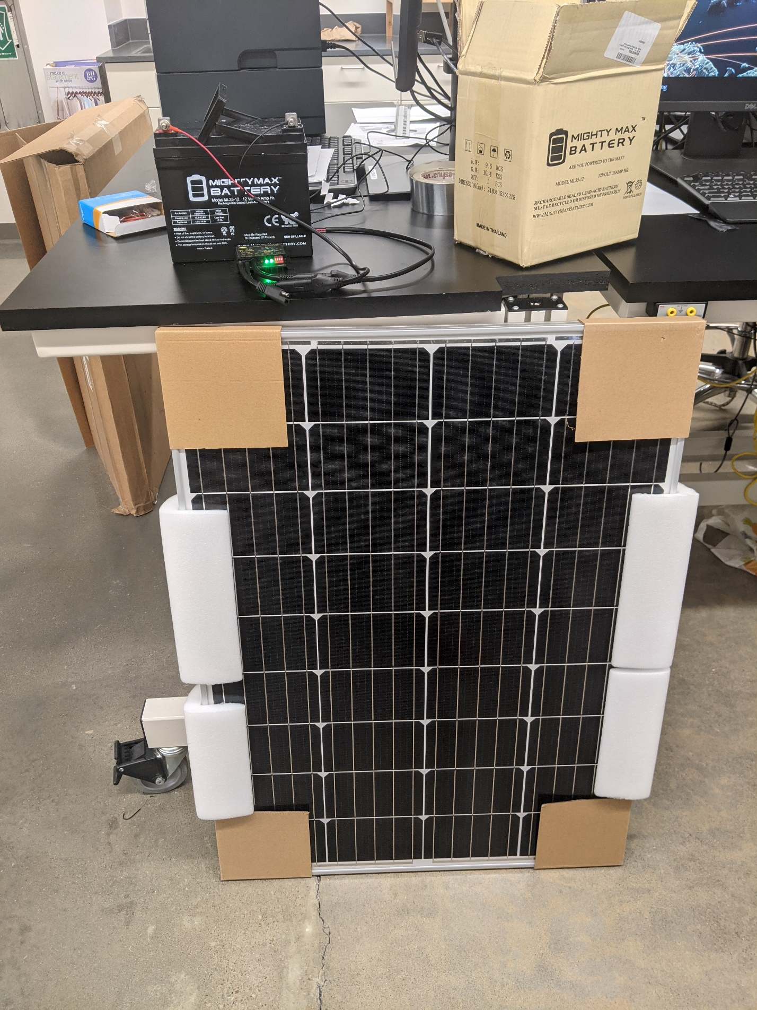

Figure 2. Assemblies 1BT1 Solar Panel, 1U1 MPPT, 1BT2 Battery of Unit 1

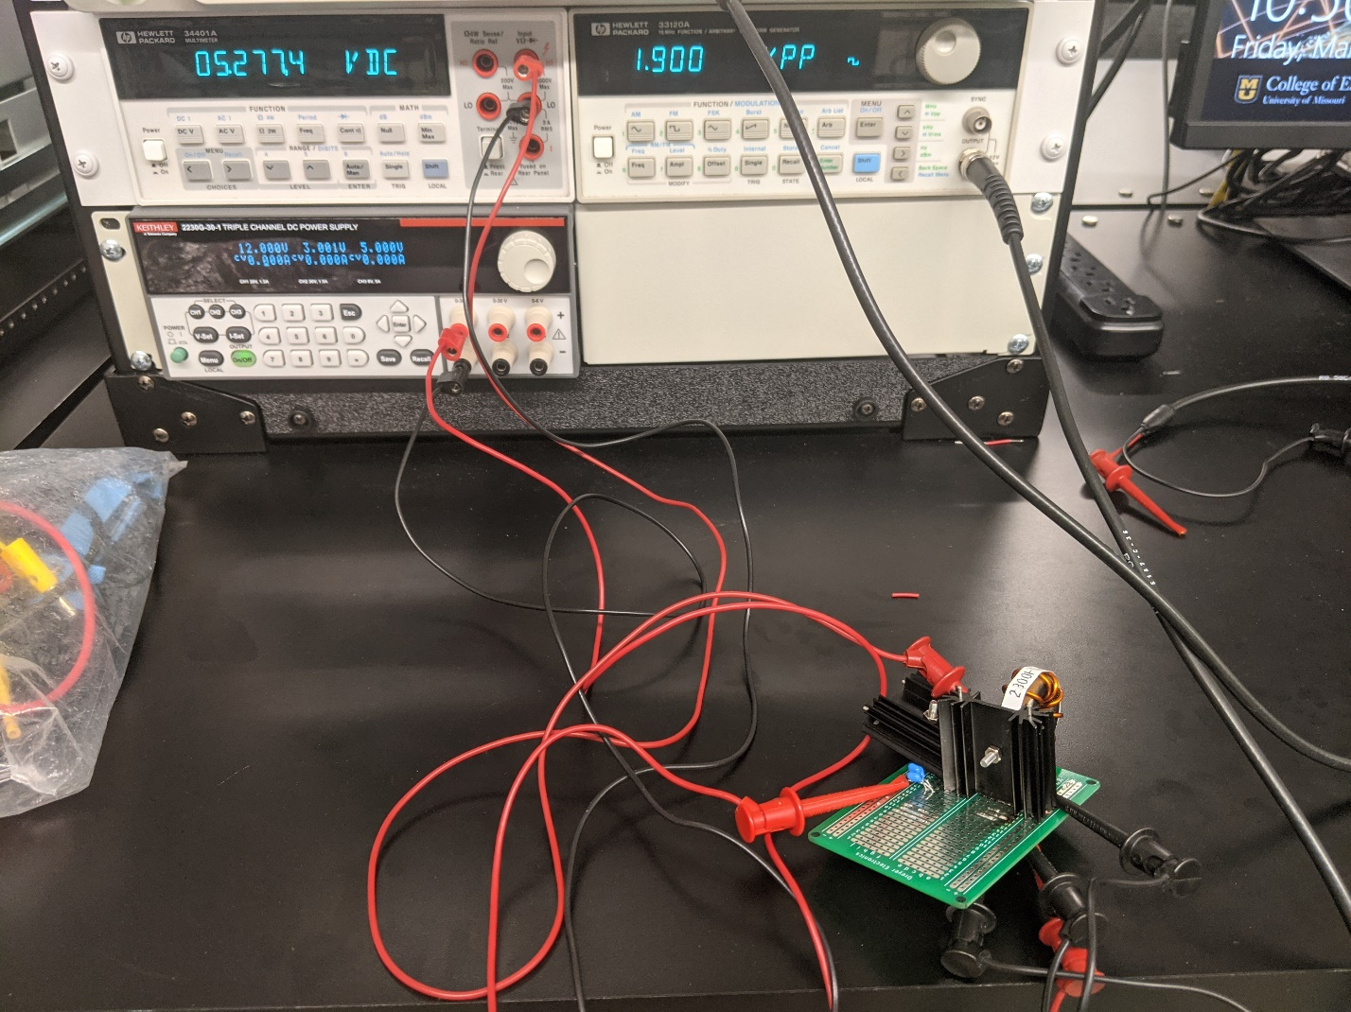

Figure 3. Unit 1, Assembly 1PS1 Power Supply with 12 V input and 5.27 V output

Note: Due to time constraints, the secondary output to the Arduino is not included since it can run directly from the battery if needed.

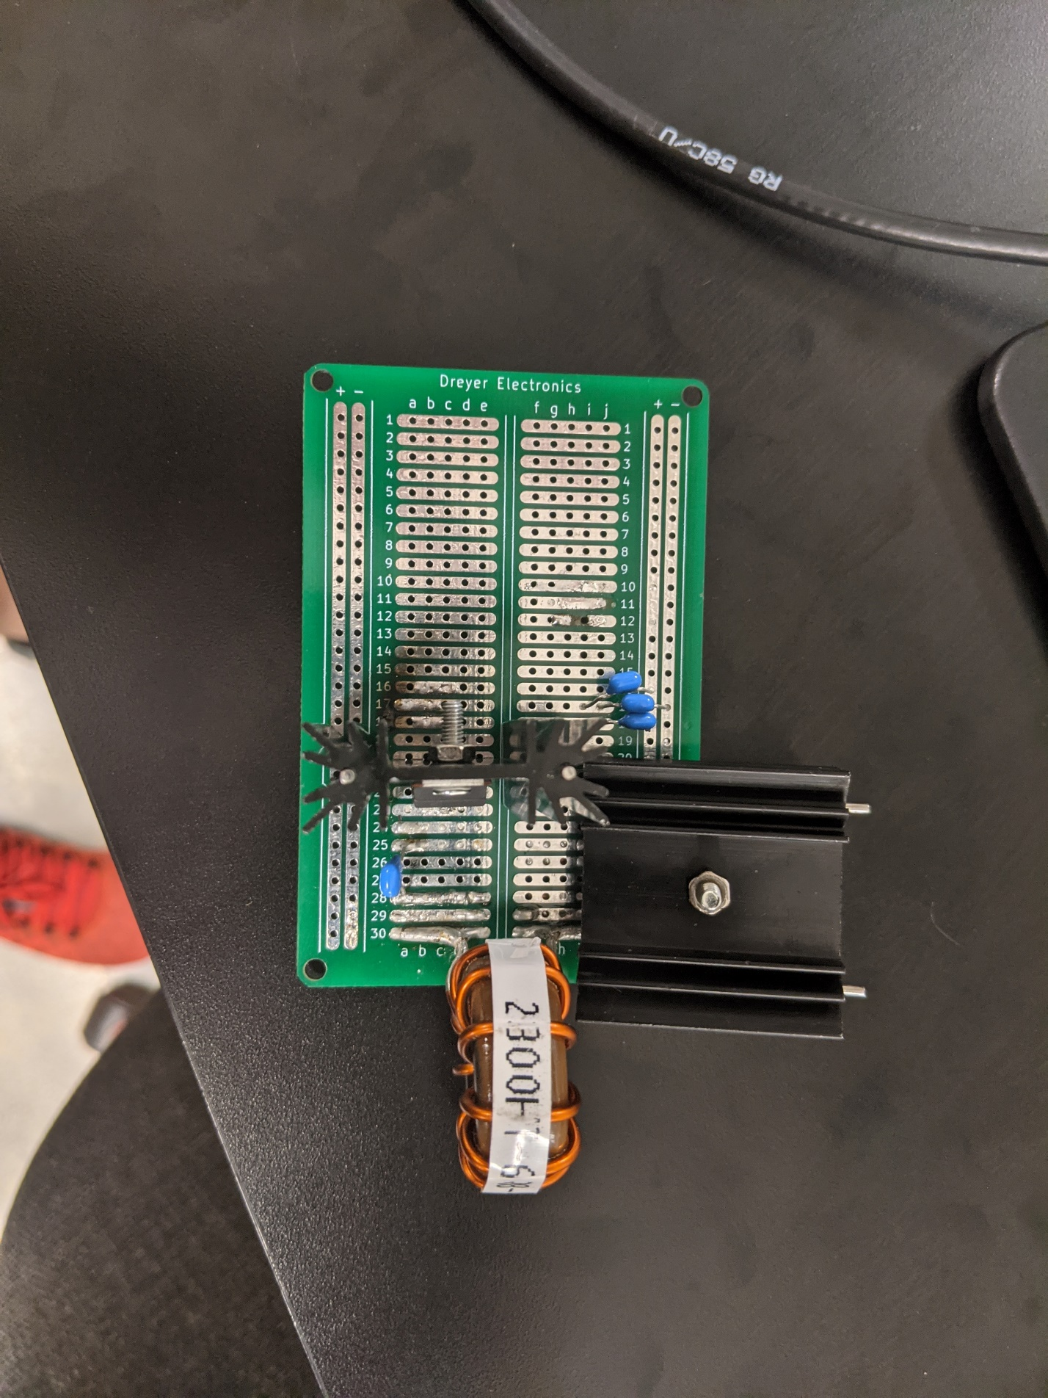

Figure 4. 1PS1 top view

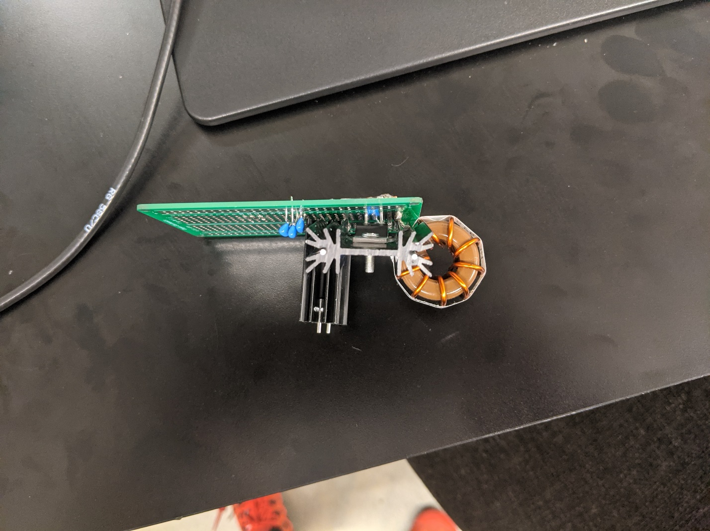

Figure 5. 1PS1 side view

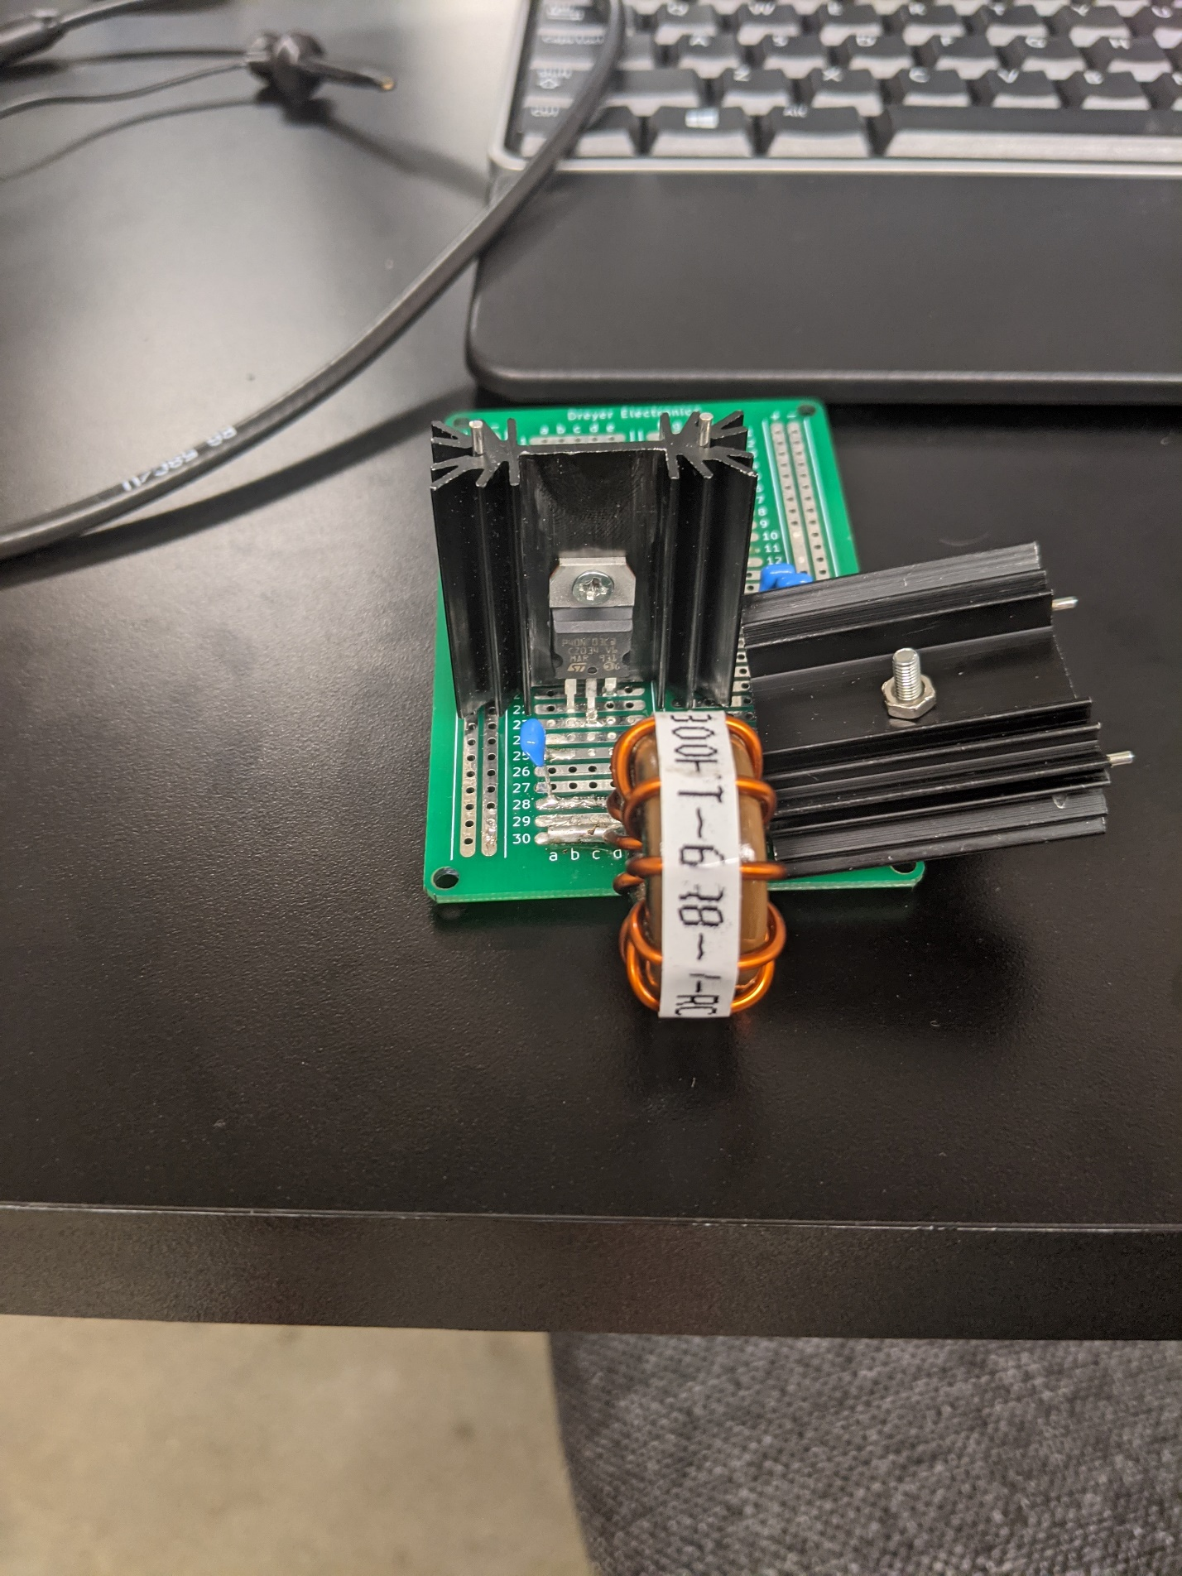

Figure 6. 1PS1 front view